#include <stdio.h>
#include <string.h>

// ----------------------------
// Function Declarations
// ----------------------------
void userInterface(char productName[], char productType[]);
void inputBuffer(char productName[], char productType[], char outName[], char outType[]);
int logicEngine(char productType[]);
int scoringSystem(int score);
void outputLayer(int finalScore);

// ----------------------------
// MAIN FUNCTION
// ----------------------------
int main() {
char productName[50], productType[50];
char bufferName[50], bufferType[50];

printf("\n=== ECO-FRIENDLY SHOPPING ADVISOR ===\n");

// Step 1: UI takes input
userInterface(productName, productType);

// Step 2: Input Buffer stores inputs
inputBuffer(productName, productType, bufferName, bufferType);

// Step 3: Logic Engine processes input
int score = logicEngine(bufferType);

// Step 4: Scoring System returns final category score
int finalScore = scoringSystem(score);

// Step 5: Output Layer prints results
outputLayer(finalScore);

return 0;
}

// ----------------------------
// 1. USER INTERFACE
// ----------------------------
void userInterface(char productName[], char productType[]) {
printf("\nEnter product name: ");
scanf("%s", productName);

printf("\nEnter product type:\n");
printf("1. Organic\n2. Recycled\n3. Plastic\n4. Biodegradable\n");
printf("Enter option (1-4): ");
scanf("%s", productType);
}

// ----------------------------
// 2. INPUT BUFFER
// ----------------------------
void inputBuffer(char productName[], char productType[], char outName[], char outType[]) {
strcpy(outName, productName);
strcpy(outType, productType);
}

// ----------------------------
// 3. LOGIC ENGINE
// ----------------------------
int logicEngine(char productType[]) {
int type = atoi(productType);

// Assign a base score based on type
switch(type) {
case 1: return 90; // Organic
case 2: return 75; // Recycled
case 3: return 30; // Plastic
case 4: return 85; // Biodegradable
default: return 0; // Invalid
}
}

// ----------------------------
// 4. SCORING SYSTEM
// ----------------------------
int scoringSystem(int score) {
if(score >= 80)
return 3; // HIGH SCORE = Best Choice
else if(score >= 50)
return 2; // Medium Score = Good Choice
else
return 1; // Low Score = Avoid
}

// ----------------------------
// 5. OUTPUT LAYER
// ----------------------------
void outputLayer(int finalScore) {
printf("\n--------------------------------------");
printf("\n ECO-FRIENDLY SCORE RESULT");
printf("\n--------------------------------------\n");

if(finalScore == 3) {
printf("Result: BEST CHOICE \n");
printf("This product is highly eco-friendly.\n");
}
else if(finalScore == 2) {
printf("Result: GOOD CHOICE \n");
printf("A moderate eco-friendly product.\n");
}
else {
printf("Result: AVOID \n");
printf("Not environmentally recommended.\n");
}
printf("--------------------------------------\n");
}

Output:-
STEP-1:-
  - 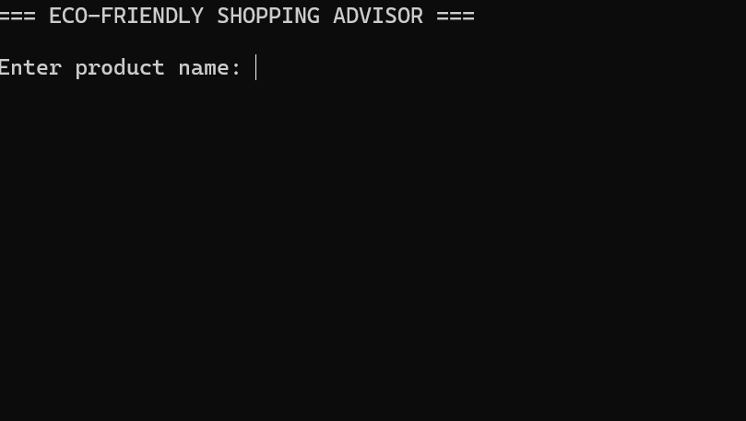
STEP-2:- 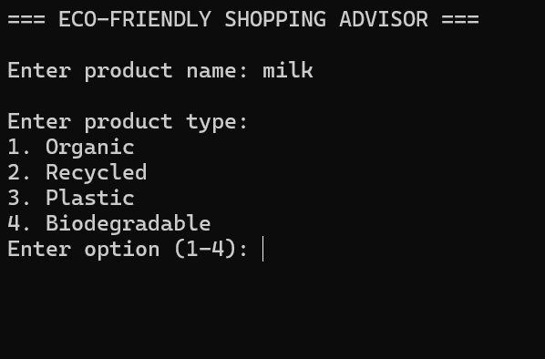
  - OR
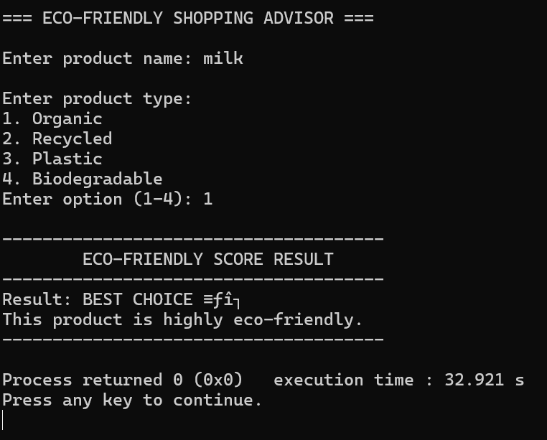

Output 1: Best Choice Result
Input:
Product Name: Milk
Product Type: Organic (1)
Explanation:
When the user selects Organic, the Logic Engine assigns a high score (90).
The Scoring System categorizes scores above 80 as “Best Choice”.
Therefore, the system displays that the product is highly eco-friendly.
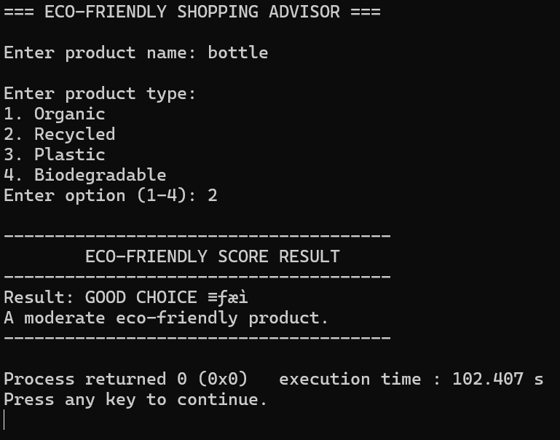

Output 2: Good Choice Result
Input:
Product Name: Bottle
Product Type: Recycled (2)
Explanation:
Recycled items receive a score of 75, which falls between 50 and 79.
The Scoring System identifies this range as “Good Choice”.
This means the product is moderately eco-friendly and acceptable for use.

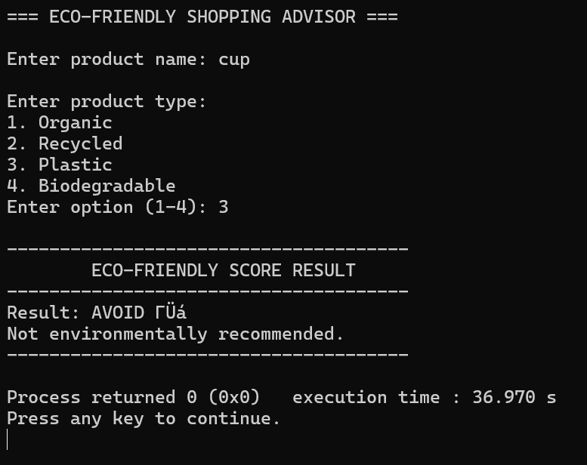

Output 3: Avoid Result
Input:
Product Name: Cup
Product Type: Plastic (3)
Explanation:
Plastic products get a low score of 30 due to their harmful environmental impact.
Scores below 50 are classified as “Avoid”.
Hence, the system warns the user that this product is not eco-friendly

